Hydraulics System Fact Sheet

Question: Can both flight hydraulic systems be turned off? Why?

Answer:

No, an interlock fail-safe system is provided by each system’s Pressure Switch. This prevents the pilot from being able to turn off both flight hydraulic systems at the same time.

a. The opposite system’s Pressure Switch makes the ground that allows the pilot to shut off the Pilot Solenoid Valve (PSV) on the system to be turned off.

b. (See diagram) When the pilot selects a system to be turned off, power from the Number Two 28 volt D.C. bus is routed from the Hydraulic System Select Switch (on the overhead control panel) to the opposite PSV as marked on the switch. When the pilot selects Number 1 system “On”, he is not actually doing anything to the Number 1 Flight Boost Hydraulic System - he is actually powering off the Number 2 System.

c. The PSV is a normally closed, electrically opened hydraulic valve. The PSV, once opened, supplies hydraulic pressure to the Pressure Operated Valve (POV) that turns off the selected hydraulic system. The POV is a normally opened, pressure closed, valve. The POV is spring loaded to the opened position. When no hydraulic pressure is supplied by the PSV to close the POV, the POV will spring load to the open position.

d. As long as there is pressure in the opposite system, the opposite system’s Pressure Switch provides the ground for the Pilot Solenoid Valve allowing it to be electrically opened.

e. Should one system fail, the ground for the opposite system is removed and the operational system cannot be turned off. This is the Fail-Safe feature of the hydraulic system.

e. To select the number one system, number two is powered off. Vice Versa, to select the number two system, number one is powered off.

f. Should an electrical failure occur where ultimately the Number 2 28 volt D.C. bus was lost, the hydraulic system would re-engage. It requires electrical power to turn off a flight hydraulics system.

g. Additionally, the Pressure Switch provides the ground to illuminate the Flight Hydraulics Off caution light and/or provides the ground signal to the AFCS, letting the computer know that sufficient hydraulic power is available to operate the system.

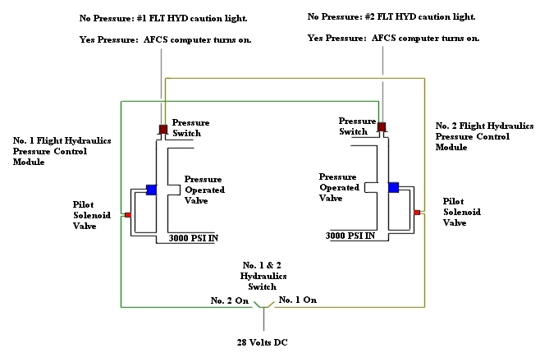

Figure 1, block diagram of Flight Boost Hydraulic Fail Safe System.

Figure 2, Flight Boost Hydraulic Pressure Control Module.

See also: TM 55-1520-240-T-1, page 7-3 and 7-4.

